Community Food Wastage Reduction Portal
Design Document

Version 1.0



Group Id: S26PROJECT51921 (BC220408429)
Supervisor Name : Dr. Hasnain Ahmed

Revision History
Date (dd/mm/yyyy) | Version | Description | Author
Current date | 1.0 | Introduction of the project | Write student(s) id

Table of Contents

- Introduction of Design Document
- Entity Relationship Diagram (ERD)
- Sequence Diagrams
- Architecture Design Diagram
- Class Diagram
- Database Design
- Interface Design
- Test Cases

- Introduction of Design Document
- Introduction of Design Document. The purpose of this design document is to provide a detailed blueprint for the Community Food Wastage Reduction Portal. This document outlines the system’s architecture, functional and non-functional requirements, database structure, and user workflows. It translates the requirements gathered in the analysis phase into a form that can be used for actual system implementation and testing.1.1 Contents of This Document. This document includes: System Overview: A brief description of the portal, its purpose, and target users. System Architecture: High-level structure showing frontend, backend, database, and external APIs. Entity Relationship Diagram (ERD): Data model showing entities like User, Donation, Request, and Pickup, and their relationships. Functional Requirements: Core features such as donation posting, matching, notifications, and tracking. Non-Functional Requirements: Performance, security, scalability, and usability constraints. User Interface Design: Wireframes and workflow for key screens like “Post Donation” and “Browse Food”.1.2 Purpose of the Design Phase in Software Development. The design phase is critical because it bridges the gap between user requirements and the actual code. Its main purposes are: Clarity and Direction: Provides developers, testers, and stakeholders a clear understanding of how the system will work before coding starts. This reduces confusion and rework. Risk Reduction: Identifying technical challenges, data relationships, and workflow issues early helps avoid costly fixes later in development. Consistency: Ensures all team members follow the same structure, naming conventions, and database design, leading to a maintainable system. Cost and Time Efficiency: A solid design prevents major changes during implementation, saving time and budget. Quality Assurance: Serves as a reference for testing. If the system matches the design, it meets the intended requirements.1.3 Benefits of This Phase for the Portal Project For the Community Food Wastage Reduction Portal, the design phase ensures: Accurate Matching: The ERD and workflow design guarantee that donors and receivers are matched correctly based on location and food type. Scalability: The architecture is planned to handle multiple NGOs and donors without performance issues. User Trust: Clear verification and tracking processes are designed to make the platform reliable. Impact Measurement: The design includes tracking metrics like food saved in kg and people served, aligning with the social goal of the project.
- Entity Relationship Diagram (ERD) (To be developed using Microsoft Visio or any other drawing software of your choice)
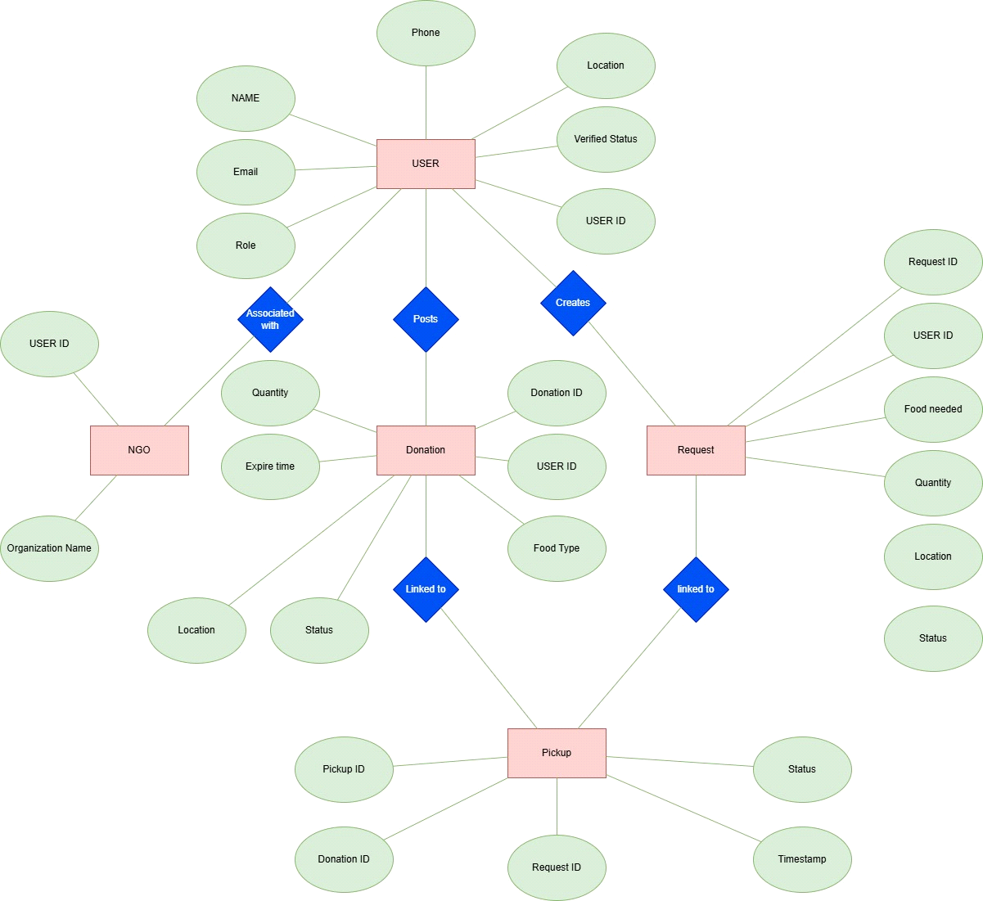
- Sequence Diagrams (To be developed using Rational Rose or any other drawing software of your choice)

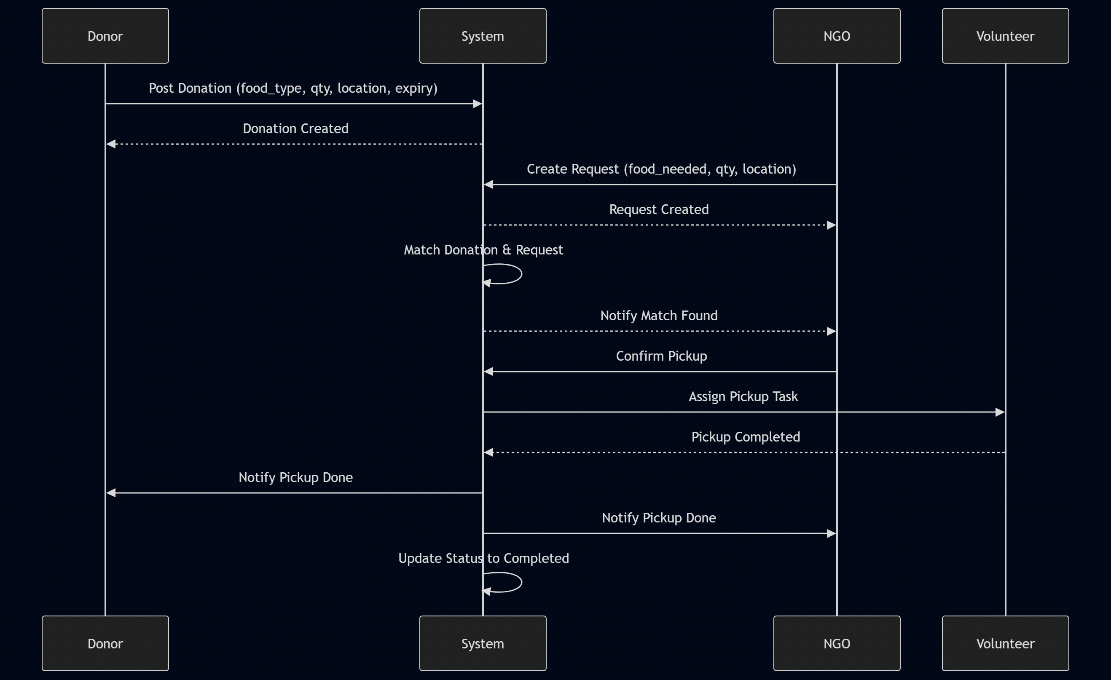

- Architecture Design Diagram
<Provide a Tiered Architecture of the system>
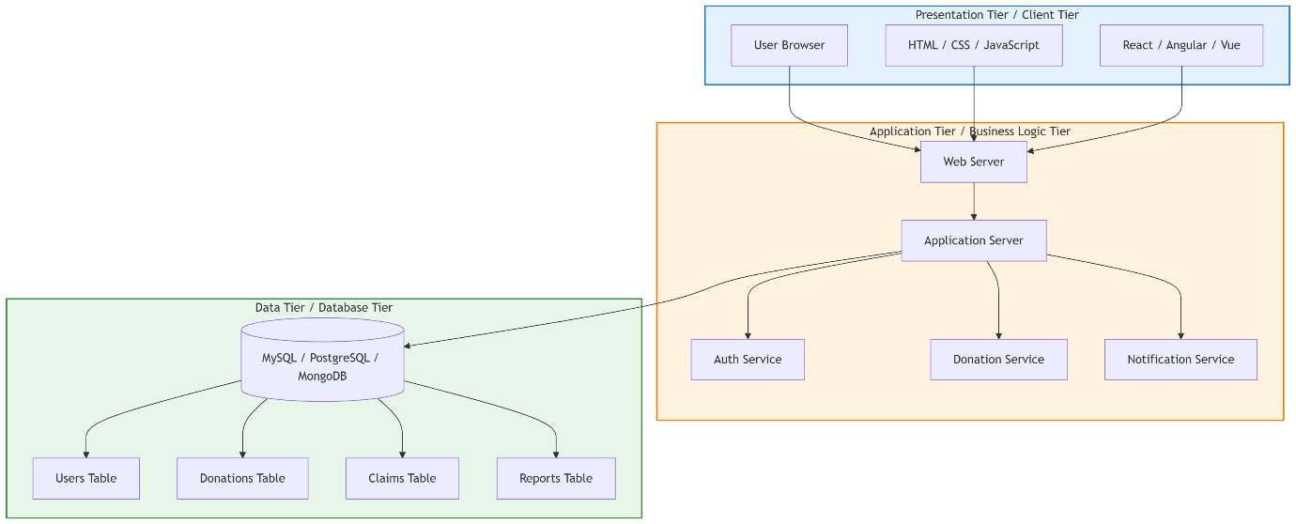

- Class Diagram

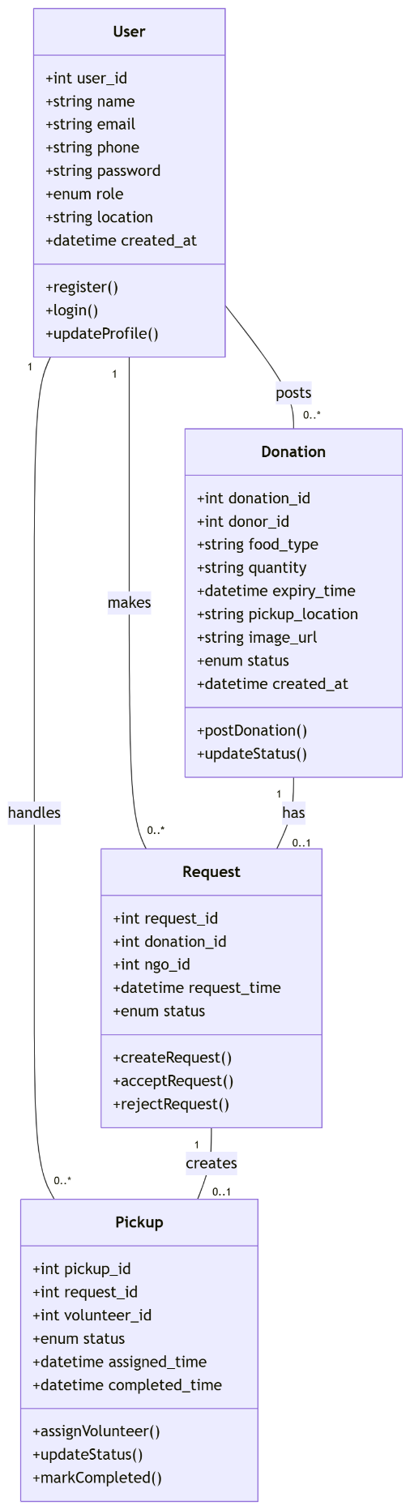

- Database Design

<Provide Database Design Diagram of the system>
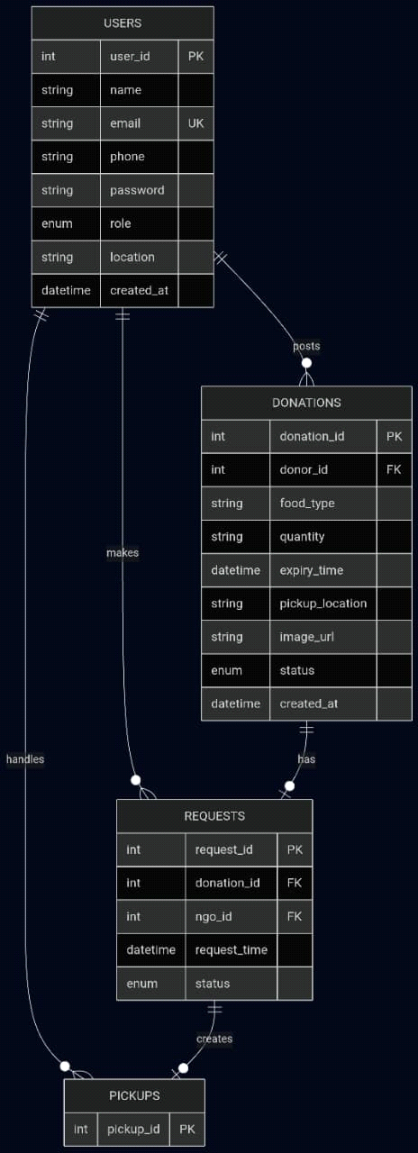

- Interface Design
Fig. 1: User Registration & Login Interface
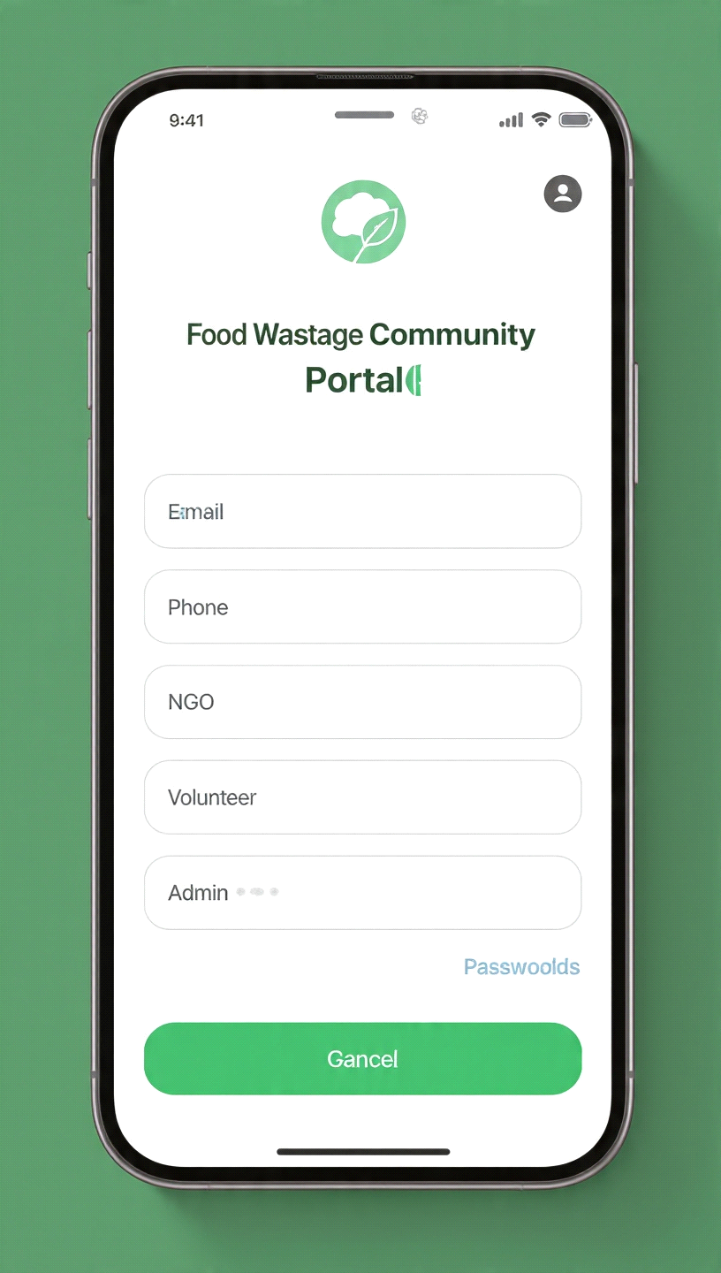

Fig. 2: Donation Posting Interface
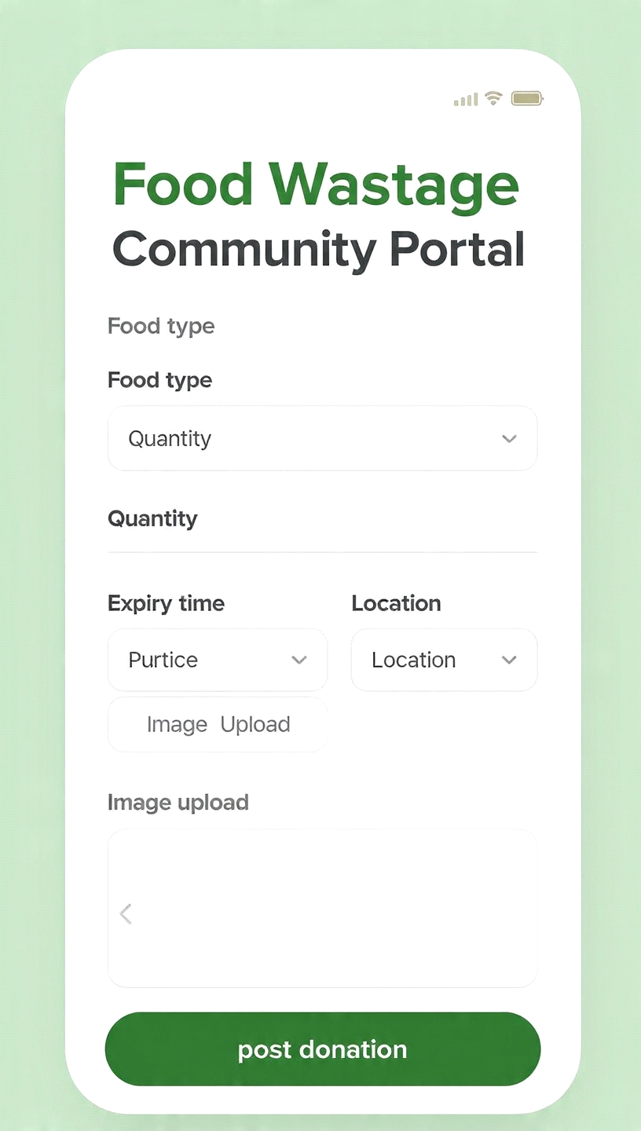

Fig. 3: Request & Matching Dashboard
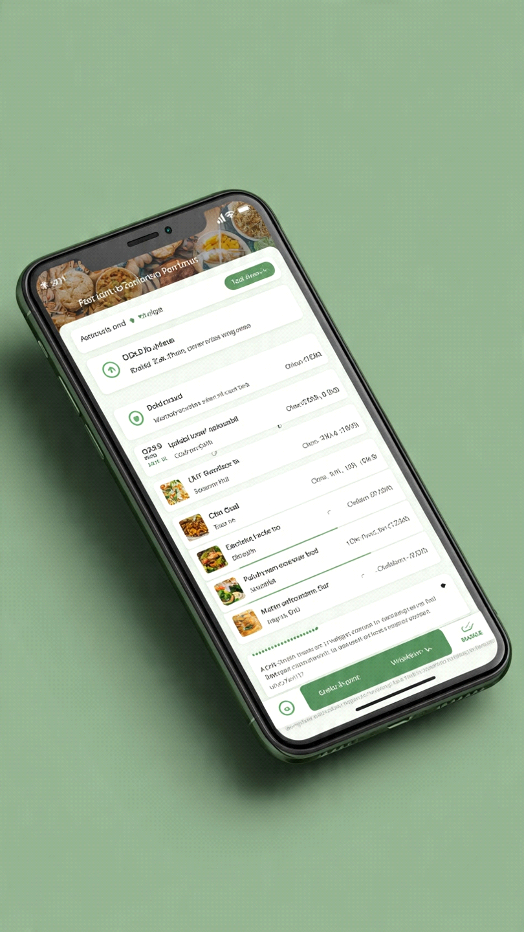

Fig. 4: Pickup & Tracking Interface
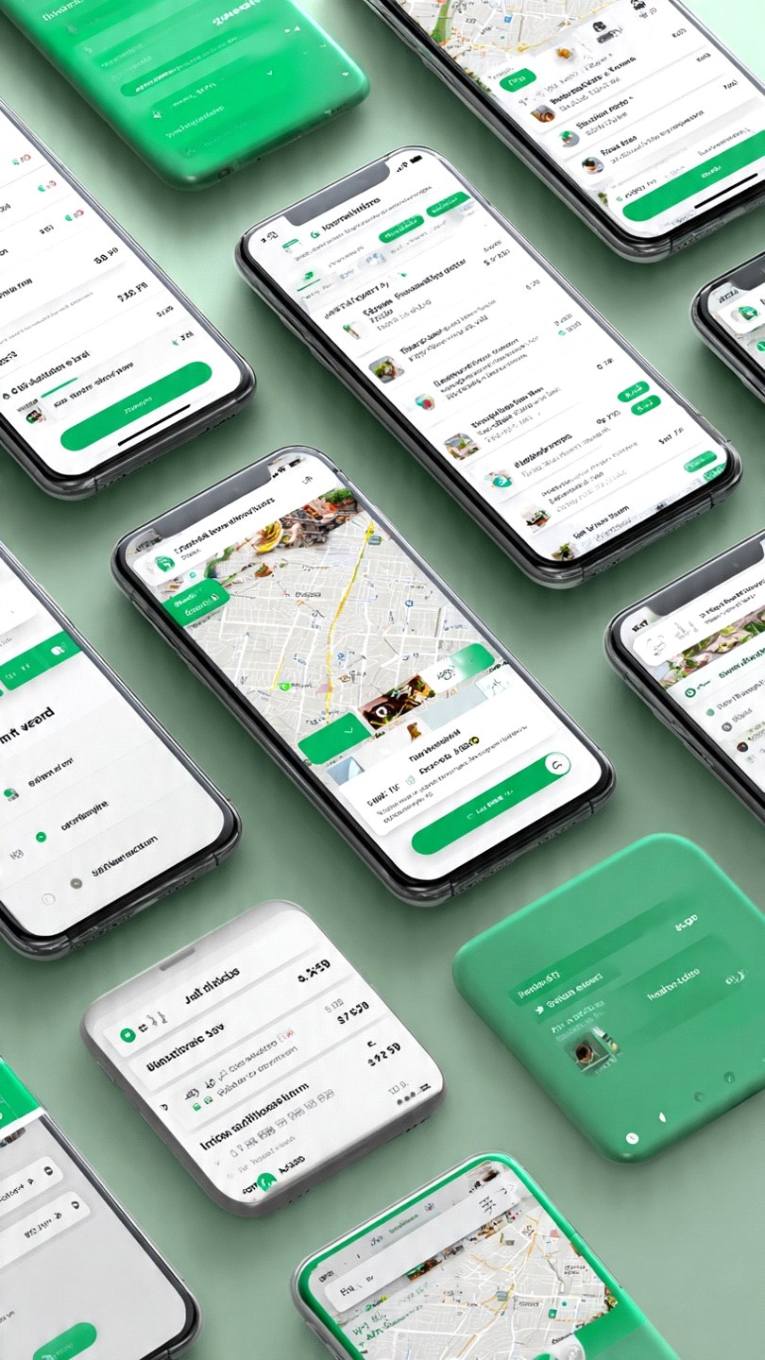

- Test Cases

1. Use Case: Donor Registers and Posts Food DonationTC001 - Valid Donation Post. Precondition: Donor account created and logged in. Steps: Click "Post Donation". Fill food type, quantity, expiry time, pickup location. Submit. Test Data: Food Type: "Cooked Rice", Qty: 5kg, Expiry: 23:00 today, Location: "Lahore Plaza". Expected Result: Donation appears in "Available Food" list. Success message shown. Pass/Fail: Pass if donation is visible to NGOs within 5sTC002 - Submit Donation with Expired Food. Precondition: Donor logged in. Steps: Enter expiry time in the past and submit. Expected Result: Validation error "Expiry time cannot be in the past". Pass/Fail: Pass if submission is blocked2. Use Case: NGO Claims Food DonationTC003 - Valid Claim. Precondition: NGO logged in, donation is "Available". Steps: Click "Claim" on a donation, confirm. Expected Result: Status changes to "Claimed". Donor gets notified. Pass/Fail: Pass if status updates and notification sentTC004 - Claim Already Claimed Donation. Precondition: Donation status is "Claimed". Steps: Try to claim the same donation. Expected Result: Error "This donation is already claimed". Pass/Fail: Pass if claim is rejected3. Use Case: User RegistrationTC005 - Valid Registration. Precondition: User on signup page. Steps: Enter name, email, phone, password, select role [Donor/NGO/Volunteer], submit. Test Data: Email: test123@mail.com, Password: Test@123Expected Result: Account created, redirect to login. Pass/Fail: Pass if user appears in DB and can loginTC006 - Duplicate Email Registration. Precondition: Email already exists in system. Steps: Register with same email. Expected Result: Error "Email already registered". Pass/Fail: Pass if duplicate is rejected4. Use Case: Search and Filter DonationsTC007 - Filter by Location. Precondition: Multiple donations exist in different cities. Steps: Select "Sargodha" in location filter, apply. Expected Result: Only donations from Sargodha are shown. Pass/Fail: Pass if no out-of-city results appear5. Use Case: Report WastageTC008 - Valid Wastage Report. Precondition: User logged in. Steps: Submit report with location, estimated quantity, image upload. Expected Result: Report saved, admin notified. Pass/Fail: Pass if report appears in admin dashboard

